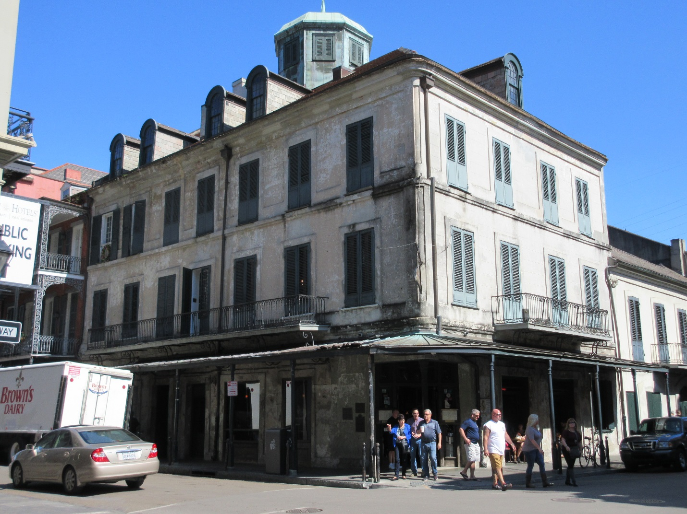1.12 Napoleon House (Girod House)

*1814, attributed to Jean-Hyacinthe Laclotte. 500–506 Chartes St. (Vieux Carré)*

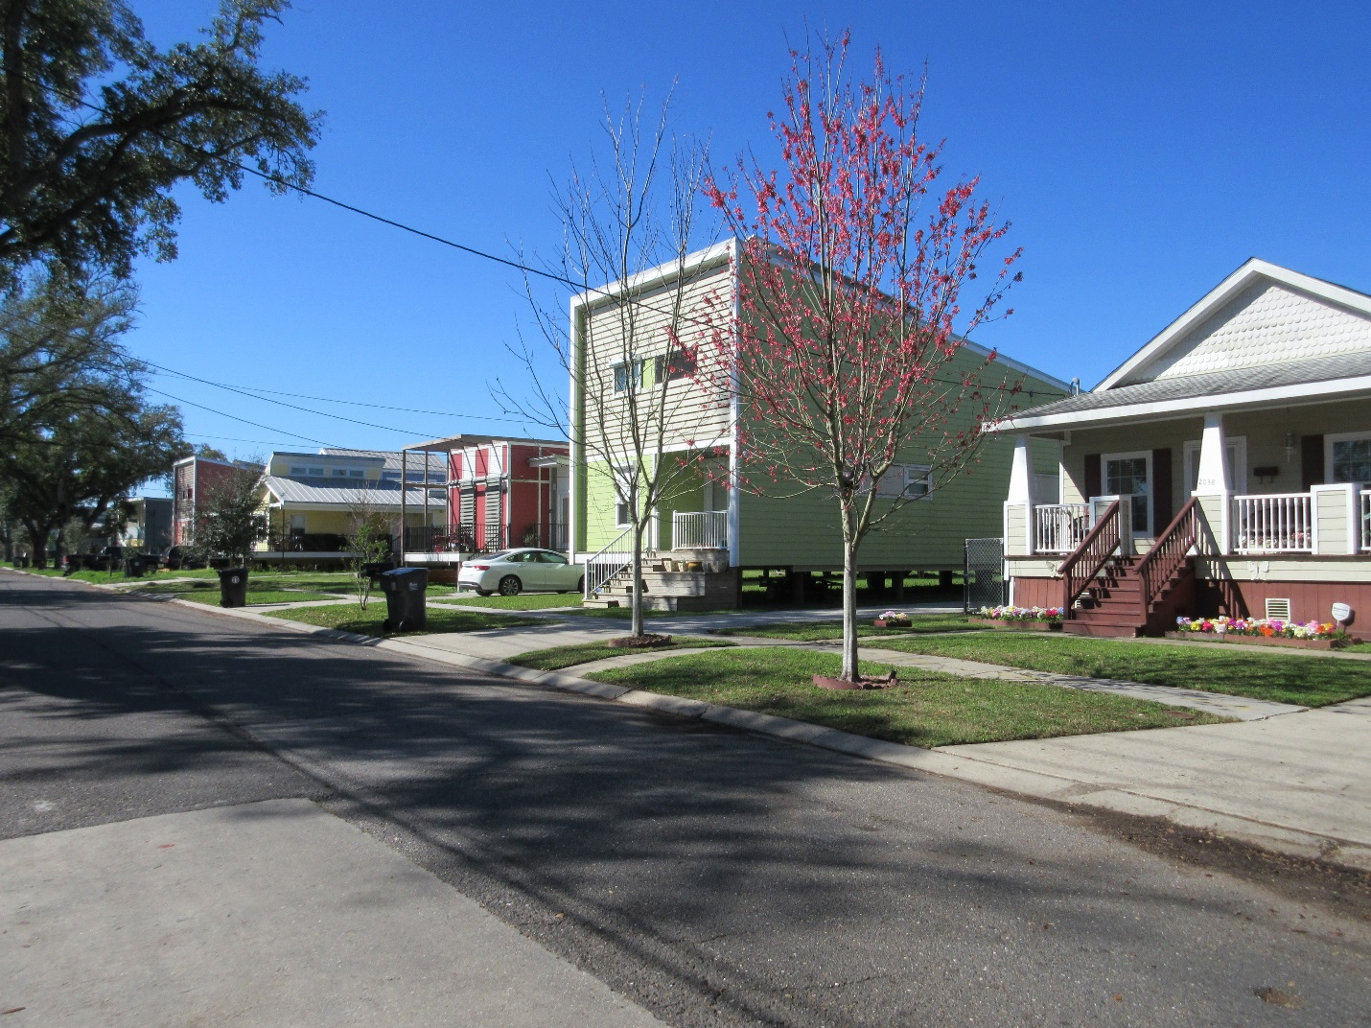3.15 Make It Right Houses

*2005 and later. Roughly bounded by N. Claiborne and Jourdain aves. and Reynes and N. Galvez sts. (Lower Ninth Ward)*

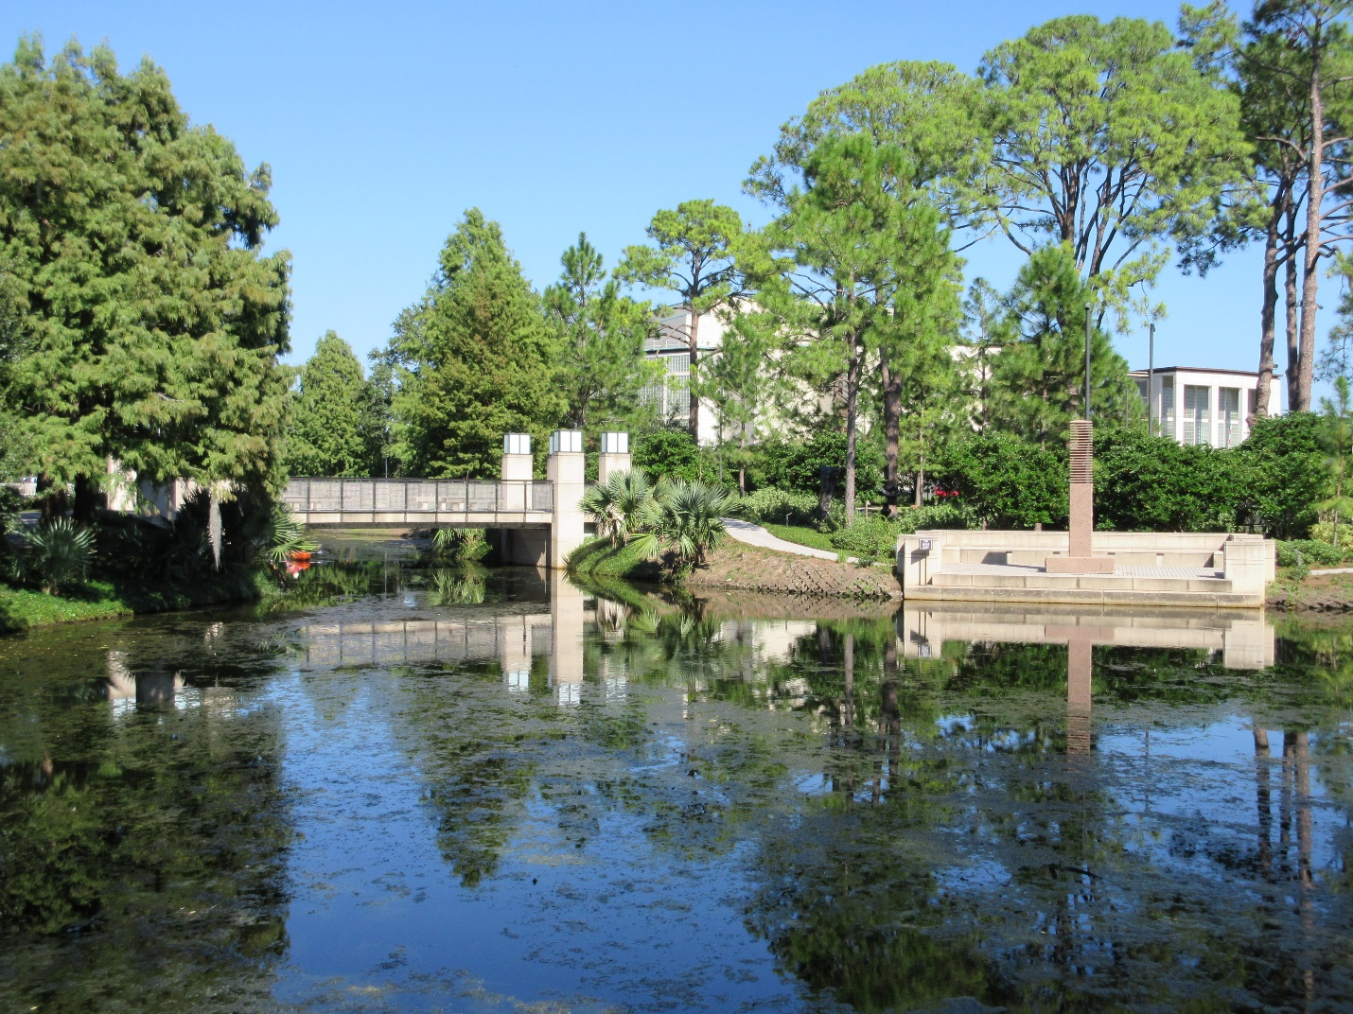4.16 Sydney and Walda Besthoff Sculpture Garden

*2003, Lee Ledbetter and Associates and Sawyer/Berson. Collins Diboll Cir. (Esplanade Avenue/City Park)*

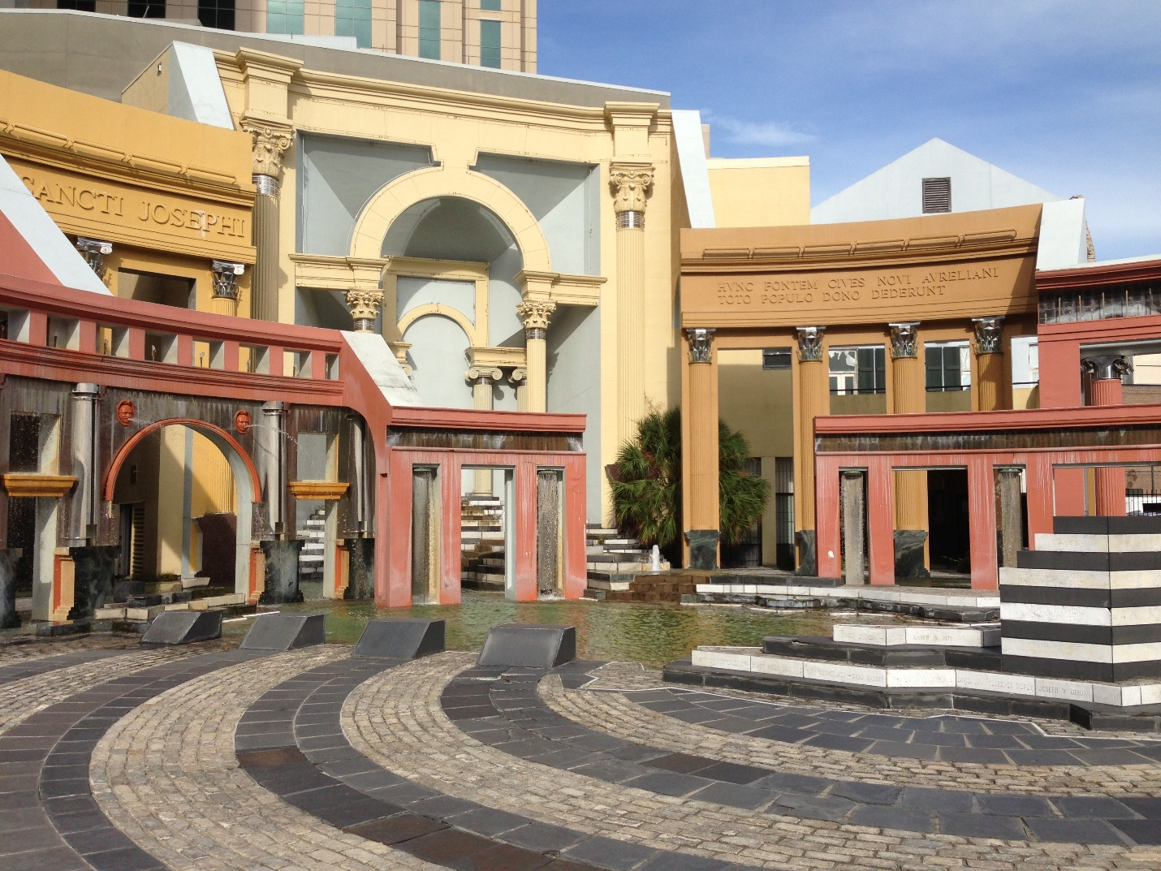6.21 Piazza d’Italia

*1975–1978, August Perez and Associates, and Charles Moore for Urban Innovations Group; 2003 restored, Hewitt-Washington and Associates; 2017 renovated, Torre Design Consortium. Bounded by Poydras, Tchoupitoulas, Lafayette, and Commerce sts. (Central Business District)*

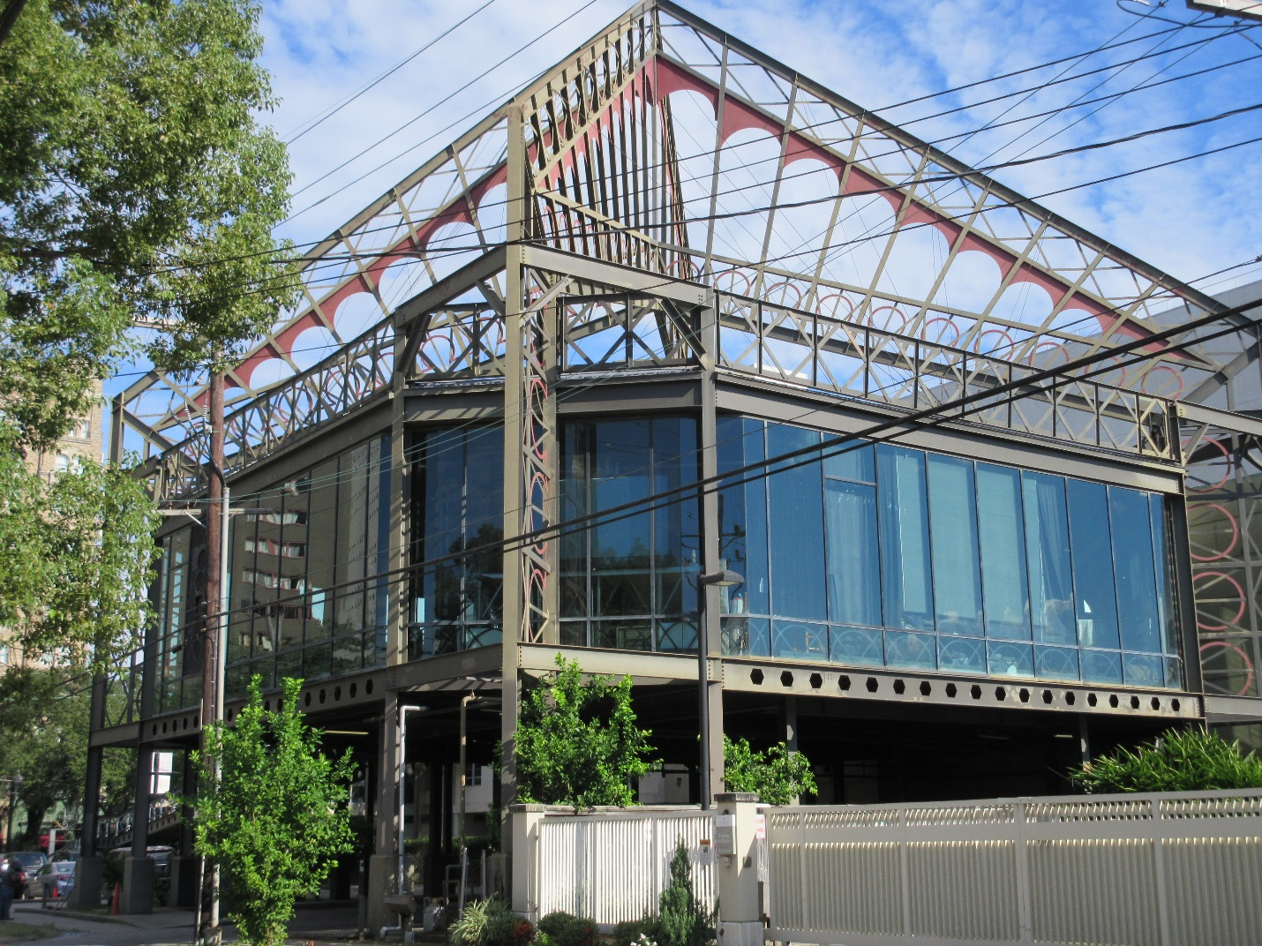7.8 The Eiffel Society (Eiffel Tower Restaurant)

*1986, Concordia Architects. 2040 St. Charles Ave. (Garden District)*

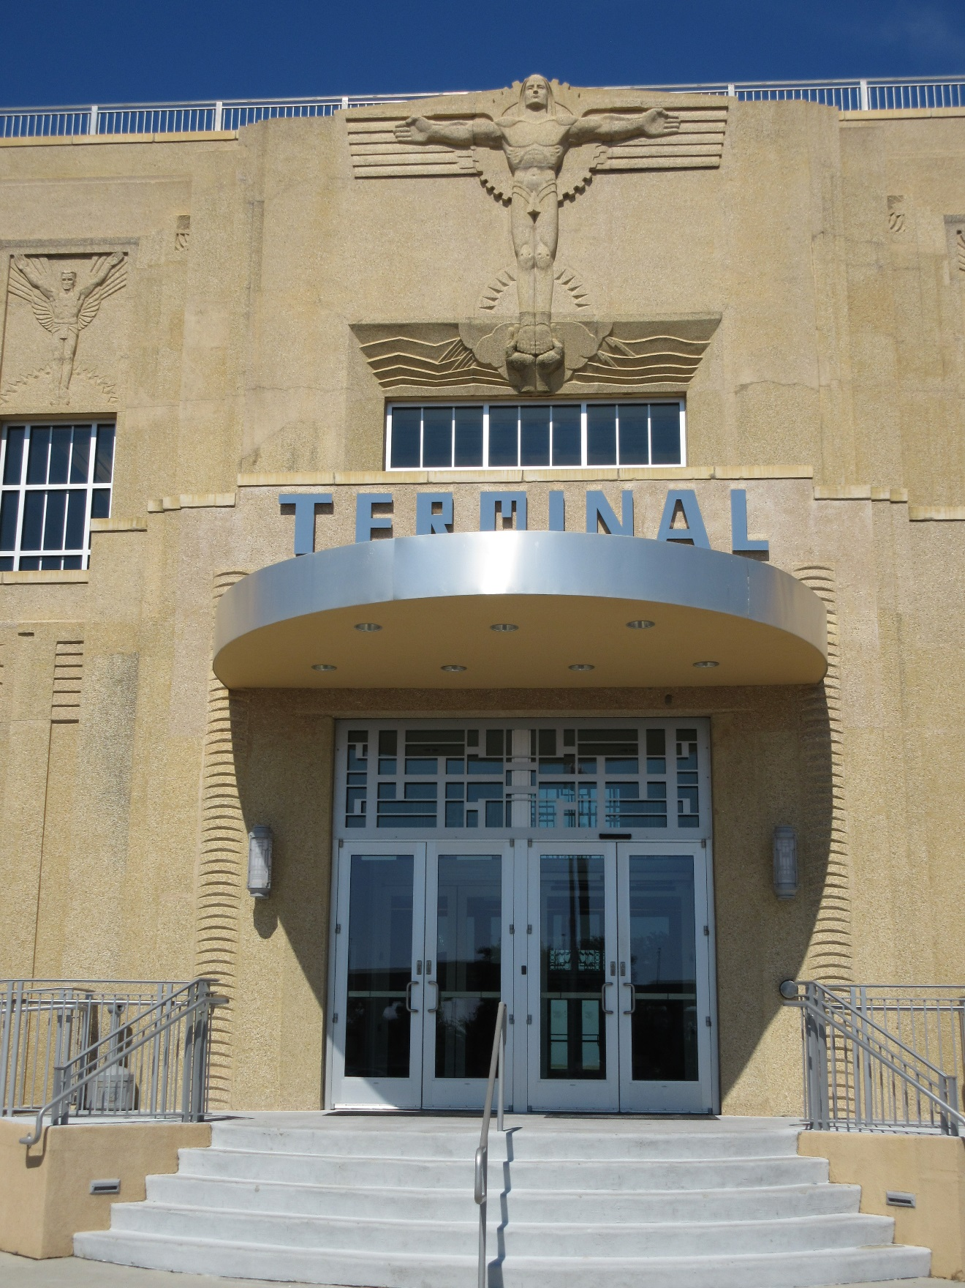11.5 Lakefront Airport (Shushan Airport)

*1932–1934, Weiss, Dreyfous and Seiferth; 2013 restored, Alton Ochsner Davis. 6001 Stars and Stripes Blvd. (Lakefront)*